 |  |  |  | BTicino SpA  Vale Borri 231 - 21100 Varese - Italy  Tel. +39 0244878.1 - Fax +39 024503448
 | Nemo SX - Pulse concentrator module |  |  | Cat. N°: SXMIMP
 | 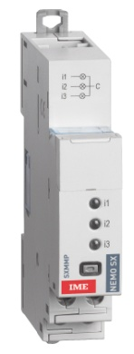 |  |  |  |  | Contents Pages  1. Description - Use 1  2. Range 1  3. Overall dimensions 1  4. Preparation - Connection 1  5. General characteristics 4  6. System architectures 6  6.1 Stand-alone 6  6.1.1 with local addressing 6  6.1.2 with remote addressing 7  6.2 Supervised 8  6.2.1 with local addressing 8  6.2.2 with remote addressing 10  7. Compliance and approvals 12
 | 1. DESCRIPTION - USE  . Module dedicated to Nemo SX System.  . It collects, memorises and transmits pulses in output from electrical, gas, water counters or from the pulse output of multifunction measuring devices.  Symbol:  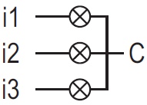  2. RANGE  . Cat. n° SXMIMP: Pulse Concentrator Module; 3 inputs from voltage-free SPST-NO contact with one common terminal.  Width:  . 1 module. 17,8 mm width.  3. OVERALL DIMENSIONS  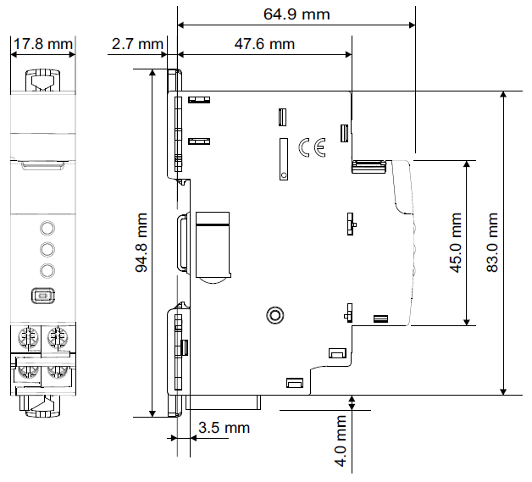 |  |  | 4. PREPARATION -CONNECTION  Fixing:  . On symmetric rail EN/IEC 60715 or DIN 35 rail  Operating positions:  . Vertical, Horizontal, Upside down, On the side  Power Supply:  . Mandatory in 12 VDC via the specific Power supply module Cat n°SXAA230  . Two ways:  via specific communication patch cords (cat. nos SXAC250/  500/1000) to connect at the downstream through dedicated ports  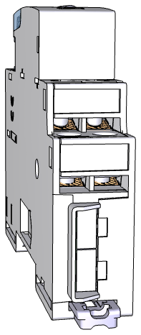  via specific communication rails (cat. nos SXAR18/24/36) to connect at the rear through dedicated connectors  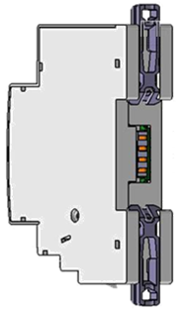
 | Technical data sheet: IDP000167EN_05 | Updated: 05/05/2021 |  |  | Created: 31/08/2017

 | Nemo SX - Pulse concentrator module |  |  | Cat. N°: SXMIMP
 | 4. PREPARATION –CONNECTION (continued)  Terminals:  . Terminal depth: 8 mm.  . Stripping length: 8 mm  Screw head:  . Mixed, slotted and Pozidriv n°1 (UNI7596 type Z1).  Recommended tightening torque:  . 1 Nm.  Recommended tools:  . For the terminals: Pozidriv n°1 or flat screwdriver 4 mm.  . For fixing: flat screwdriver 5.5 mm (6 mm maximum).  Conductor type:  Wiring diagrams:  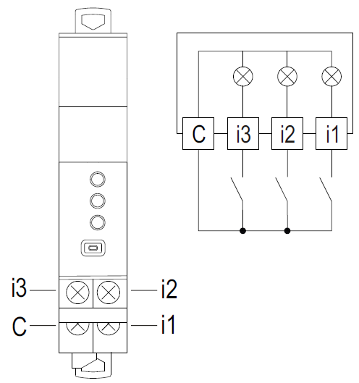  Note:  . Inputs from voltage-free SPST NO contacts  . Cable length: max. 1000 m  . Resistance of the circuit: R_{max} ≤ 125 Ω @ 25°C |  |  | 4. PREPARATION –CONNECTION (continued)  Data connection (Nemo SX modules inter-connection):  . Via specific communication patch cords (cat. nos SXAC250/  500/1000)  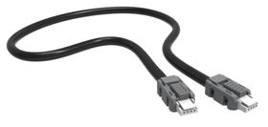  Allow data transmission between the different Nemo SX modules.  This type of connection is recommended when there are few Nemo SX modules, distributed all over the enclosure.  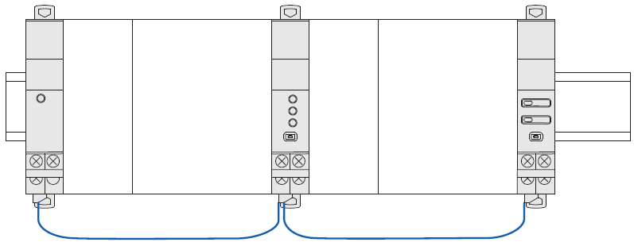  Implementing: with this configuration, the plastic protection cover of the backside communication ports on the Nemo SX module must be keep on.  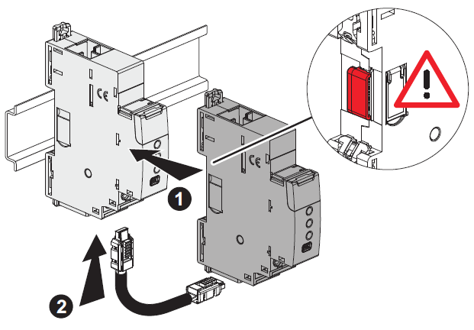
   | Copper cable
   | Without ferrule | With ferrule
  Rigid Cable | 1 x 0,5 mm² to 1,5 mm²  2 x 1,5 mm² | -
  Flexible Cable | 1 x 0,5 mm² to1,5 mm²  2 x 1,5 mm² | 1 x 0,5 mm² to 1,5 mm²  2 x 1,5 mm²
 | Technical data sheet: IDP000167EN_05 | Updated: 05/05/2021 |  |  | Created: 31/08/2017 | 

 | Nemo SX - Pulse concentrator module |  |  | Cat. N°: SXMIMP
 | 4. PREPARATION –CONNECTION (continued)  Data connection (Nemo SX modules inter-connection) (continued):  . Via specific communication rails (cat. nos SXAR18/24/36).  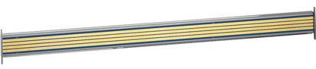  . Allow data transmission between the different Nemo SX modules.  This type of connection is recommended when there are several Nemo SX modules on the same DIN row.  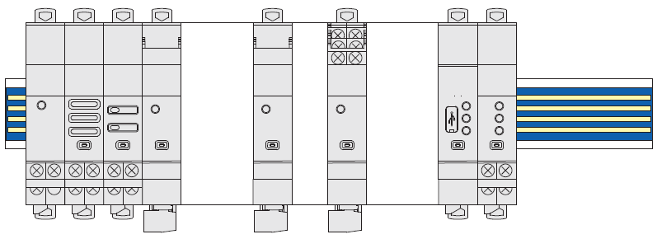  Implementing: with this configuration, the plastic protection cover of the backside communication ports on the Nemo SX module must be removed.  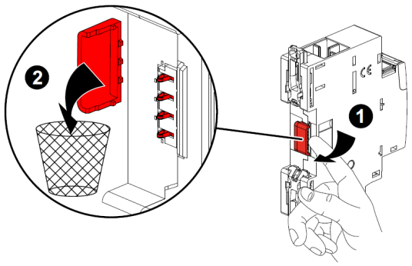  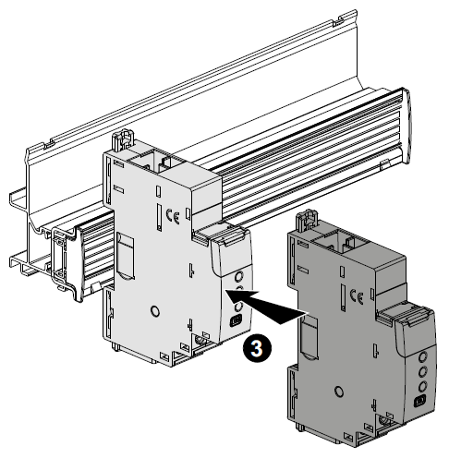 |  |  | 4. PREPARATION –CONNECTION (continued)  Data connection (Nemo SX modules inter-connection) (continued):  . Via a mix between specific communication patch cords and communication rails in order to create a link between several rows  Two situations:  - Individually connected with communication rails.  The communication patch cord allows to connect two rows.  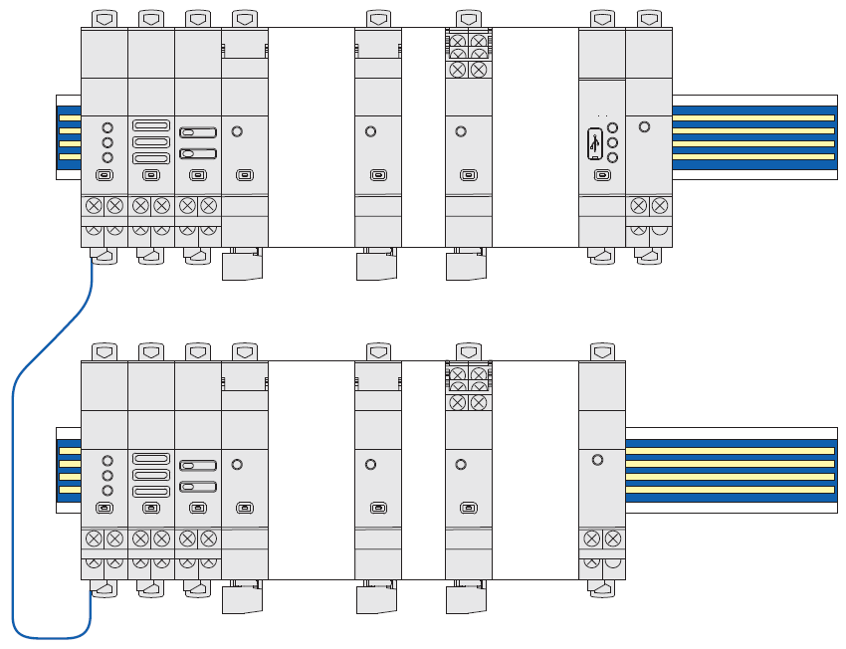  - Individually connected with communication patch cords & communication rail.  The communication patch cords allow to connect Nemo SX module on a row and to connect two rows.  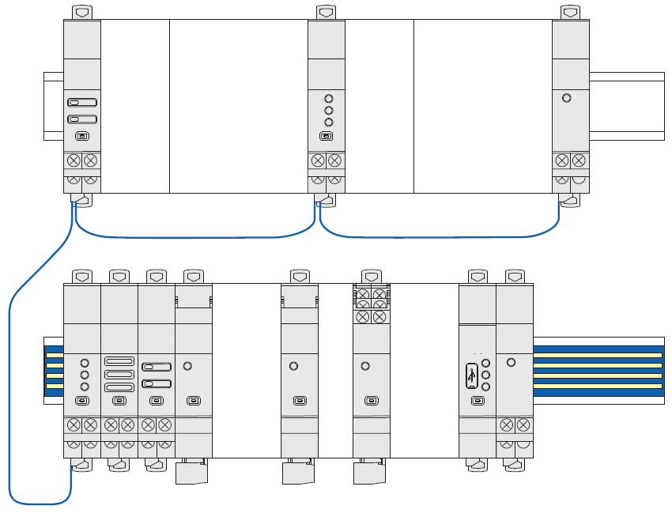
 | Technical data sheet: IDP000167EN_05 | Updated: 05/05/2021 |  |  | Created: 31/08/2017

 | Nemo SX - Pulse concentrator module |  |  | Cat. N°: SXMIMP
 | 5. GENERAL CHARACTERISTICS  Cabling information  LED linked to the input i1  LED linked to the input i3  Front face marking:  . By permanent ink pad printing (red line) and laser marking  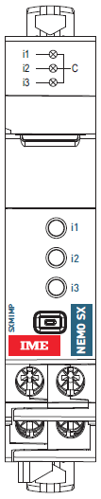  LED linked to the input i2  Electrical diagram  Lateral side marking:  . By laser.  left side: Standard and programming information  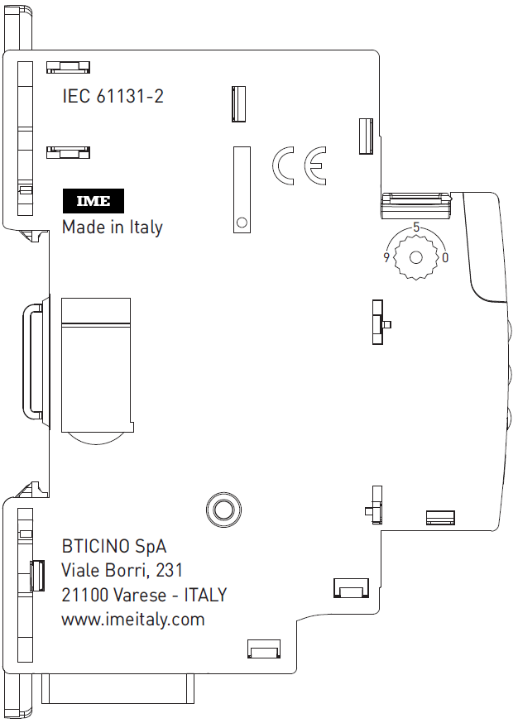  Headquarter address  Indicates the presence of the addressing track-wheel  Standards  right side: cabling and traceability information  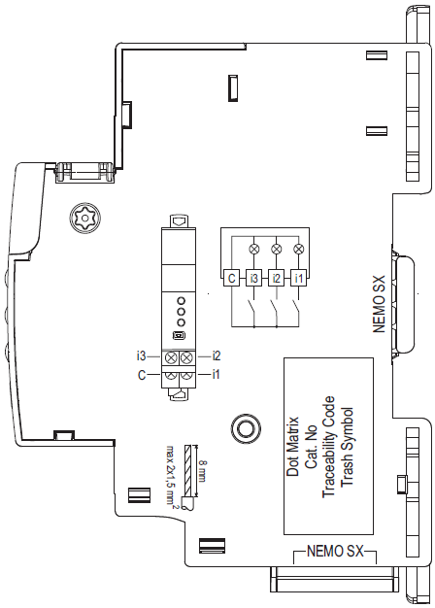  Label: to be removed from the module and kept if necessary (module ID info ...)  Traceability information  Data connection with communication patch cords  Data connection with communication rail  Wiring diagram |  |  | 5. GENERAL CHARACTERISTICS (continued)  Measuring LEDs:  . The device is equipped with 3 signalling LEDs indicating that the module has received a pulse in input:  - blinking red → one light pulse each impulse received  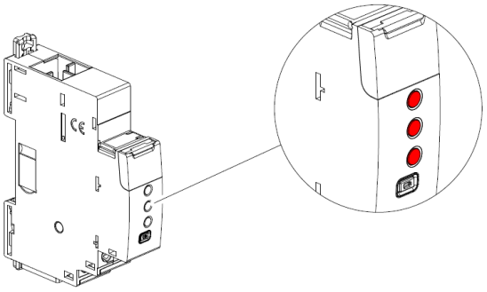  Multi-Functions button:  . Front face button as several functions:  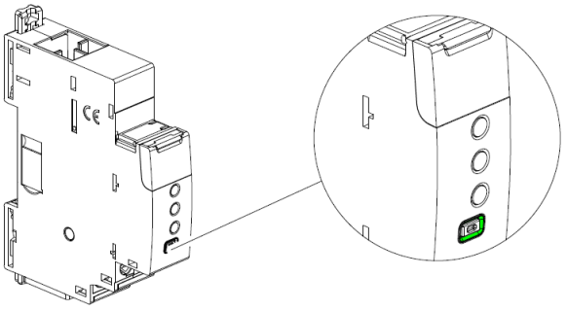  . Gives information about the operating state on the module  Possible states:
  Colour | State | Meaning
  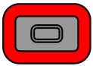red | Slow blinking | Error (e.g. addressing error)
   | Fast blinking | No function
   | Steady  (pressing the multifunction button longer than 10 sec.) | Total reset  [any firmware updates are preserved]
  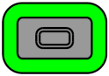green | Slow blinking | System process is running.  Wait until the Led turns steady
   | Fast blinking  (pressing the multifunction button for 5 sec.) | put in “Stand-by” the Nemo SX module (no remote action and communication available)
   | Steady | System OK, connection is running
  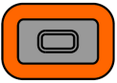orange | Slow blinking | No function | P&L info (refer to next paragraph)
   | Fast blinking | Device’s firmware update in progress
   | Steady | No function
 | Technical data sheet: IDP000167EN_05 | Updated: 05/05/2021 |  |  | Created: 31/08/2017

 | Nemo SX - Pulse concentrator module |  |  | Cat. N°: SXMIMP
5. GENERAL CHARACTERISTICS (continued)
Inputs characteristics:
. N° of inputs: 3 passives
. Input type: potential free SPST-NO contact
. Connections: 3 inputs with common point
. Input pulse waveform: ON state: ≥ 20 ms
. Input frequency: max. 25 Hz
. Engineering units programmable, possible values: pulses, Wh, kWh, MWh, varh, kvarh, Mvarh, VAh, kVAh, MVAh, m³, km³, Mm³, Nm³, kNm³, MNm³, J, kJ, MJ, cal, kcal, g, kg, t, L (*), dm³ (*).
. Pulse weight programmable, possible values: from 0,01 to 32767
(*) available from the firmware version 1.5.7 (Production date indicated on the label sticked on the side of the module ≥ 21W23)
Note:
. Default configuration for the 3 inputs: 10 Wh/imp
. All the configuration can be made via IME - Nemo SX configurator software (download for free) or via Nemo SX Mini configurator module (cat. no SXV01)
Insulation voltage:
. Ui = 400 V
Impulse withstand voltage Uimp:
. Nemo SX ports / Input terminals:
wave 1,2 / 50 μs: 6 kV
alternate current 50 Hz / 1 min.: 3 kV
Pollution degree:
. 2 according to IEC/EN 60898-1.
Overvoltage category:
. III
Dielectric strength:
. 2500 V
Plastic material:
. Self-extinguishing polycarbonate.
. Heat and fire resistant according to IEC/EN 60695-2-12, glow-wire test at 960°C.
. Classification UL 94 / IECEN 60695-11-10: V1
Ambient operating temperature:
. Min. = -25°C. Max. = +70°C
Ambient storage temperature:
. Min. = -40°C. Max. = +70°C
Protection Index:
. Protection index of terminals against direct contacts:
IP2X (IEC/EN 60529).
. Protection index of terminals against solid and liquid bodies (wired device): IP 20 (IEC/EN 60529).
. Protection index of the front face against solid and liquid bodies: IP 40 (IEC/EN 60529).
. Class II, front panel with faceplate.
Average weight per device:
. 0,054 kg.
Volume when packed:
. 0,21 dm³.
Consumption:
. Values at 12 VDC
24,0 mA 0,288 W
 | Technical data sheet: IDP000167EN_05 | Updated: 05/05/2021 |  |  | Created: 31/08/2017

 | Nemo SX - Pulse concentrator module |  |  | Cat. N°: SXMIMP
6. SYSTEM ARCHITECTURES
The Nemo SX is a polyvalent system and, according to the needs of the customer, can be set up and/or used as “Stand-alone” or “Supervised” system. Based on this choice the configuration and addressing methods are different.
Four possible architectures are provided:
6.1 Stand-alone system
6.1.1 with local addressing (through the track wheel)
6.1.2 with remote addressing (through a computer)
6.2 Supervised (Computer Supervisory System)
6.2.1 with local addressing
6.2.2 with remote addressing
6.1 Stand-alone system
. Stand-alone = autonomous system. To be used by the end-user if it is not necessary to have a computer for the supervision outside the envelope. Everything can be managed on site.
6.1.1 Stand-alone system with local addressing (through the track wheel)
Local addressing advantages:
- No configuration software needed to set-up the installation
- It is not necessary to use a computer to manage settings (configurations, test, ...) and to use the system (visualize and be alerted, ...). Everything can be done through the Mini configuration module (local display, cat. no SXV01). [Refer to the technical sheet dedicated to this module for details].
- No communication Interfaces or gateways are required.
- Installation can be done without the intervention of a System Integrator
Programming procedure:
. For Nemo SX modules which need some: mandatory through the lateral DIP-switches of each Nemo SX module (see § ”Module configuration”)
Addressing procedure:
. For all Nemo SX modules: mandatory through the track wheel located on the top upper face of each Nemo SX modules
. Marked from 0 to 9 in order to locally define the Modbus address of the Nemo SX modules
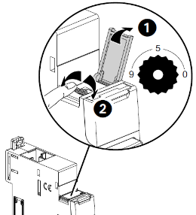
Note for Measure Module “3x single phase”:
This module is to be consider as 3 modules with 3 different Modbus Address. The module takes automatically the two addresses immediately following to the programmed one (e.g. Programmed address = 12, Addresses of the module 12, 13, 14)

Consequences of the local addressing mode (through the track wheel):
. Each device of the system must be addressed.
. Addresses available: from 1 to 9
. Address 0 not permitted
. It is possible to assign to several devices the same address with the purpose of grouping different functions, because they are related to the same electrical circuit. For example, it is possible to assign the same address to a multifunction signalling module (cat. no SXMC02), a multifunction control module (cat. no SXM0C1), a measuring module, and so on. In this way on the Nemo SX mini configuration module (local display) the grouped function will be displayed as a unique “device” with all grouped functions. [Refer to the schemes hereunder]
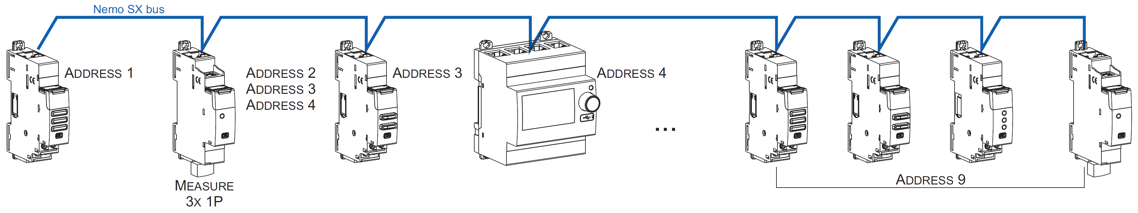
Note for the mini configuration module (local display)
. It is possible to assign it the same address as another Nemo SX through the programming menu of the device
. The mini configuration module can be placed everywhere in the Nemo SX bus

 | Technical data sheet: IDP000167EN_05 | Updated: 05/05/2021 |  |  | Created: 31/08/2017

 | Nemo SX - Pulse concentrator module |  |  | Cat. N°: SXMIMP
6. SYSTEM ARCHITECTURES
6.1 Stand-alone system (continued)
6.1.2 Stand-alone system with remote addressing (through a computer)
Remote addressing advantages:
- Whole configuration (addresses and functions) can be set up through the Nemo SX Configuration software
- Configuration software available for free
- Automatic detection of the Nemo SX modules installed in the system (characteristics, functions, configuration...)
- Increased settings possibilities: load shedding function
- Increased addressing: up to 30 Modbus addresses in a system
Programming procedure:
. For Nemo SX modules which need some: possible through the lateral DIP-switches of each Nemo SX module or via the configuration software (see § “Module configuration”).
Addressing procedure:
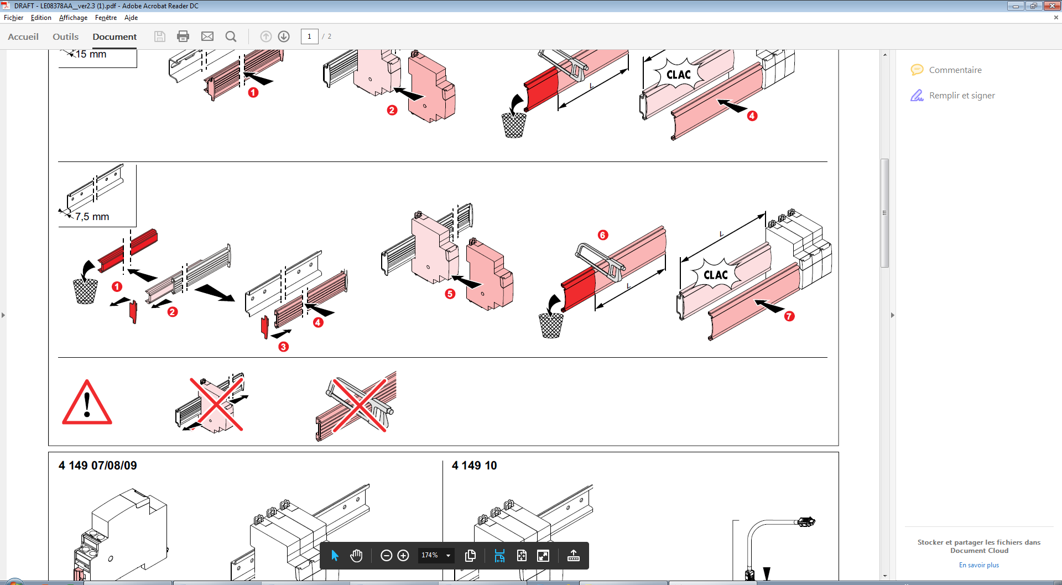
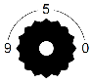
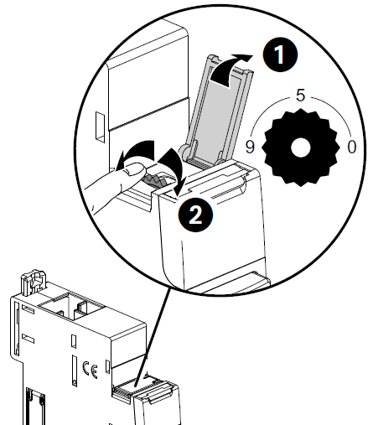
The track wheel must be left in position “0”.
. It is not necessary to address the Nemo SX modules. The track wheel must be left in default position “0”.
. All the addressing/configuring procedure will be done with the Configuration Software (available online for free)
. With remote addressing, the software does the automatic detection of modules installed in the system, but the supervision is not possible until the user assigns the remote address and all the characteristics to each module.
Note: it is mandatory to connect the computer to the Mini configuration module with a “type B” micro - USB cable. [For more details, refer to the technical data sheet of the Mini configuration module Nemo SX]
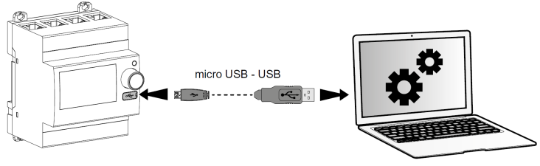
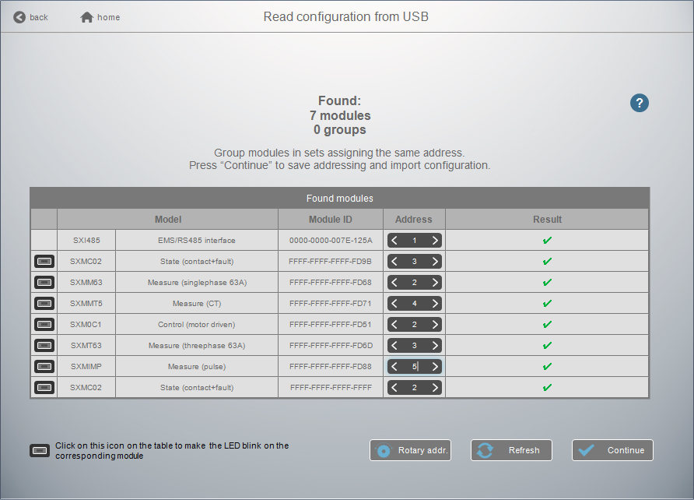

Note for Measure Module “3x single phase”:
This module is to be consider as 3 modules with 3 different Modbus Address. The module takes automatically the two addresses immediately following to the programmed one (e.g. Programmed address = 2, Addresses of the module 2, 3, 4)

 | Technical data sheet: IDP000167EN_05 | Updated: 05/05/2021 |  |  | Created: 31/08/2017

 | Nemo SX - Pulse concentrator module |  |  | Cat. N°: SXMIMP
6. SYSTEM ARCHITECTURES
6.1 Stand-alone system (continued):
6.1.2 Stand-alone system with remote addressing (through a computer) (continued):
Consequences for the system architecture:
- for 1 mini configuration module (cat. no SXV01)
  - up to 30 Nemo SX modules (e.g. 30 devices grouped per functions with addresses from1 to 30)
It is possible to assign to several devices the same address with the purpose of grouping different functions, because they are related to the same electrical circuit. For example, it is possible to assign the same address to a multifunction signalling module (cat. no SXMC02), a multifunction control module (cat. no SXM0C1), a measuring module, and so on. In this way on the Nemo SX display or in a supervision system the grouped function will be displayed as a unique “device” with all grouped functions. [Refer to the schemes here under]
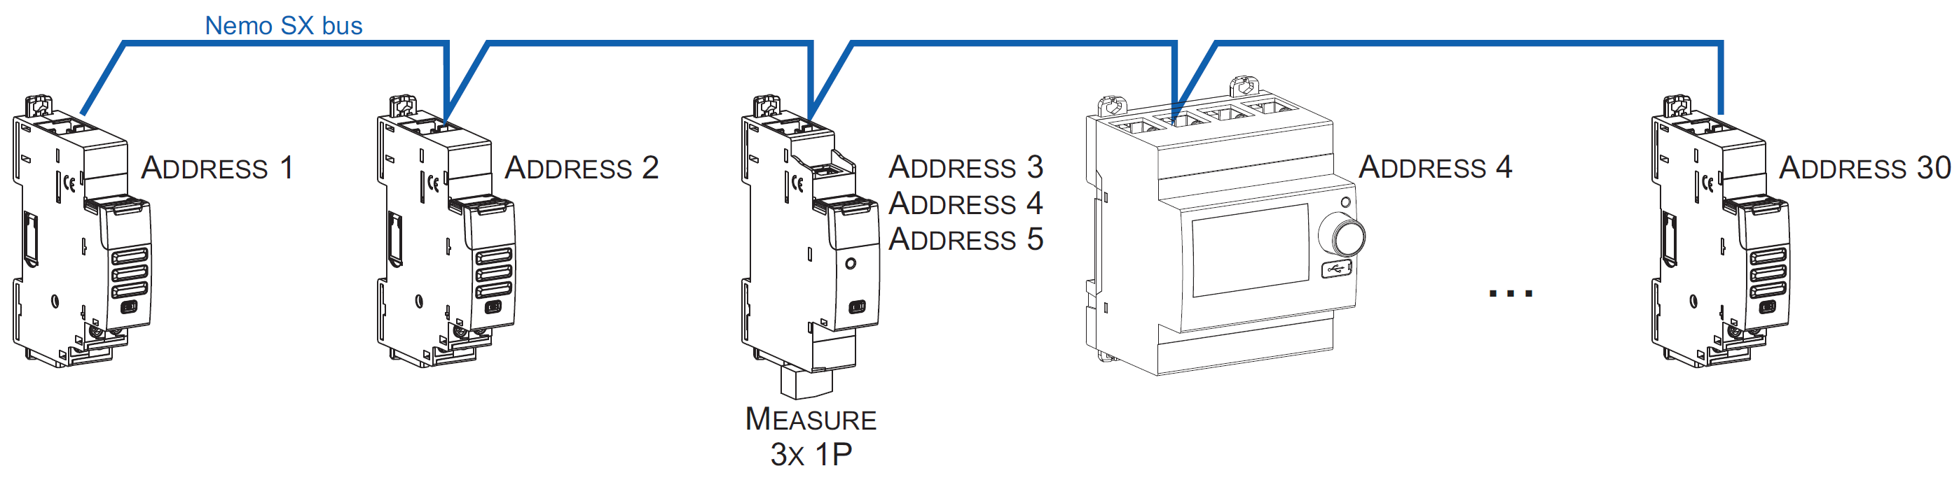
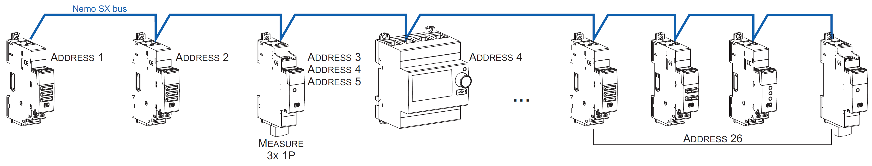
Note for the mini configuration module (local display)
. It is possible to assign it the same address as another Nemo SX
. The mini configuration module can be placed everywhere in the Nemo SX bus
6.2 Supervised system (Computer Supervisory System)
. Supervised system = System to be used through a Computer Supervisory System to remotely read data from the Nemo SX devices and/or do operations on these devices (e.g. commands of a motor driven or contactor ...).
6.2.1 Supervised system with local addressing (through the track wheel)
Local addressing advantages:
- No configuration software needed to set-up the installation
- Installation can be done without the intervention of a System Integrator
Programming procedure:
. For Nemo SX modules which need some: mandatory through the lateral DIP-switches of each Nemo SX module (see § ”Module configuration”)
Addressing procedure:
. For all Nemo SX modules: mandatory through the track wheel located on the top upper face of each Nemo SX module
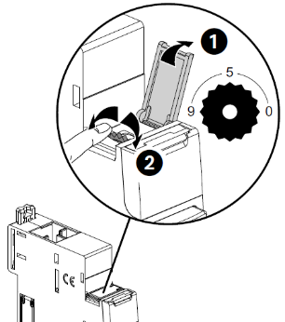
. Marked from 0 to 9 in order to locally define the Modbus address to Nemo SX modules
In this system the Modbus address of a Nemo SX Nemo SX module device or group of modules (several functions) is obtained considering the address of the interface Modbus/Nemo SX Interface as tenth and the address of a device or group of function as unit (e.g. Interface address 1 = 10 → address of module n°5 = Modbus address 15)

Note for Measure Module “3x single phase”:
This module is to be consider as 3 modules with 3 different Modbus Address. The module takes automatically the two addresses immediately following to the programmed one (e.g. Programmed address = 12, Addresses of the module 12, 13, 14)
 | Technical data sheet: IDP000167EN_05 | Updated: 05/05/2021 |  |  | Created: 31/08/2017

 | Nemo SX - Pulse concentrator module |  |  | Cat. N°: SXMIMP
6. SYSTEM ARCHITECTURES (continued)
6.2 Supervised system (Computer Supervisory System) (continued)
6.2.1 Supervised system with local addressing (through the track wheel) (continued)
Consequences of the local addressing mode (through the track wheel):
. Each device of the system must be addressed.
. Addresses available: from 1 to 9
. Address 0 not permitted
It is possible to assign to several devices the same address with the purpose of grouping different functions, because they are related to the same electrical circuit. For example, it is possible to assign the same address to a multifunction signalling module (cat. no SXMC02), a multifunction control module (cat. no SXM0C1), a measuring module, and so on. In this way on the Nemo SX display or in a supervision system the grouped function will be displayed as a unique “device” with all grouped functions. [Refer to the scheme hereunder]
Note: In this configuration the Modbus address of a Nemo SX module device or group of modules (several functions) is obtained considering the address of the interface Modbus/Nemo SX Interface as tenth and the address of a device or group of function as unit (e.g. Interface address 1 = 10 and device address = 5 → Modbus address = 15)
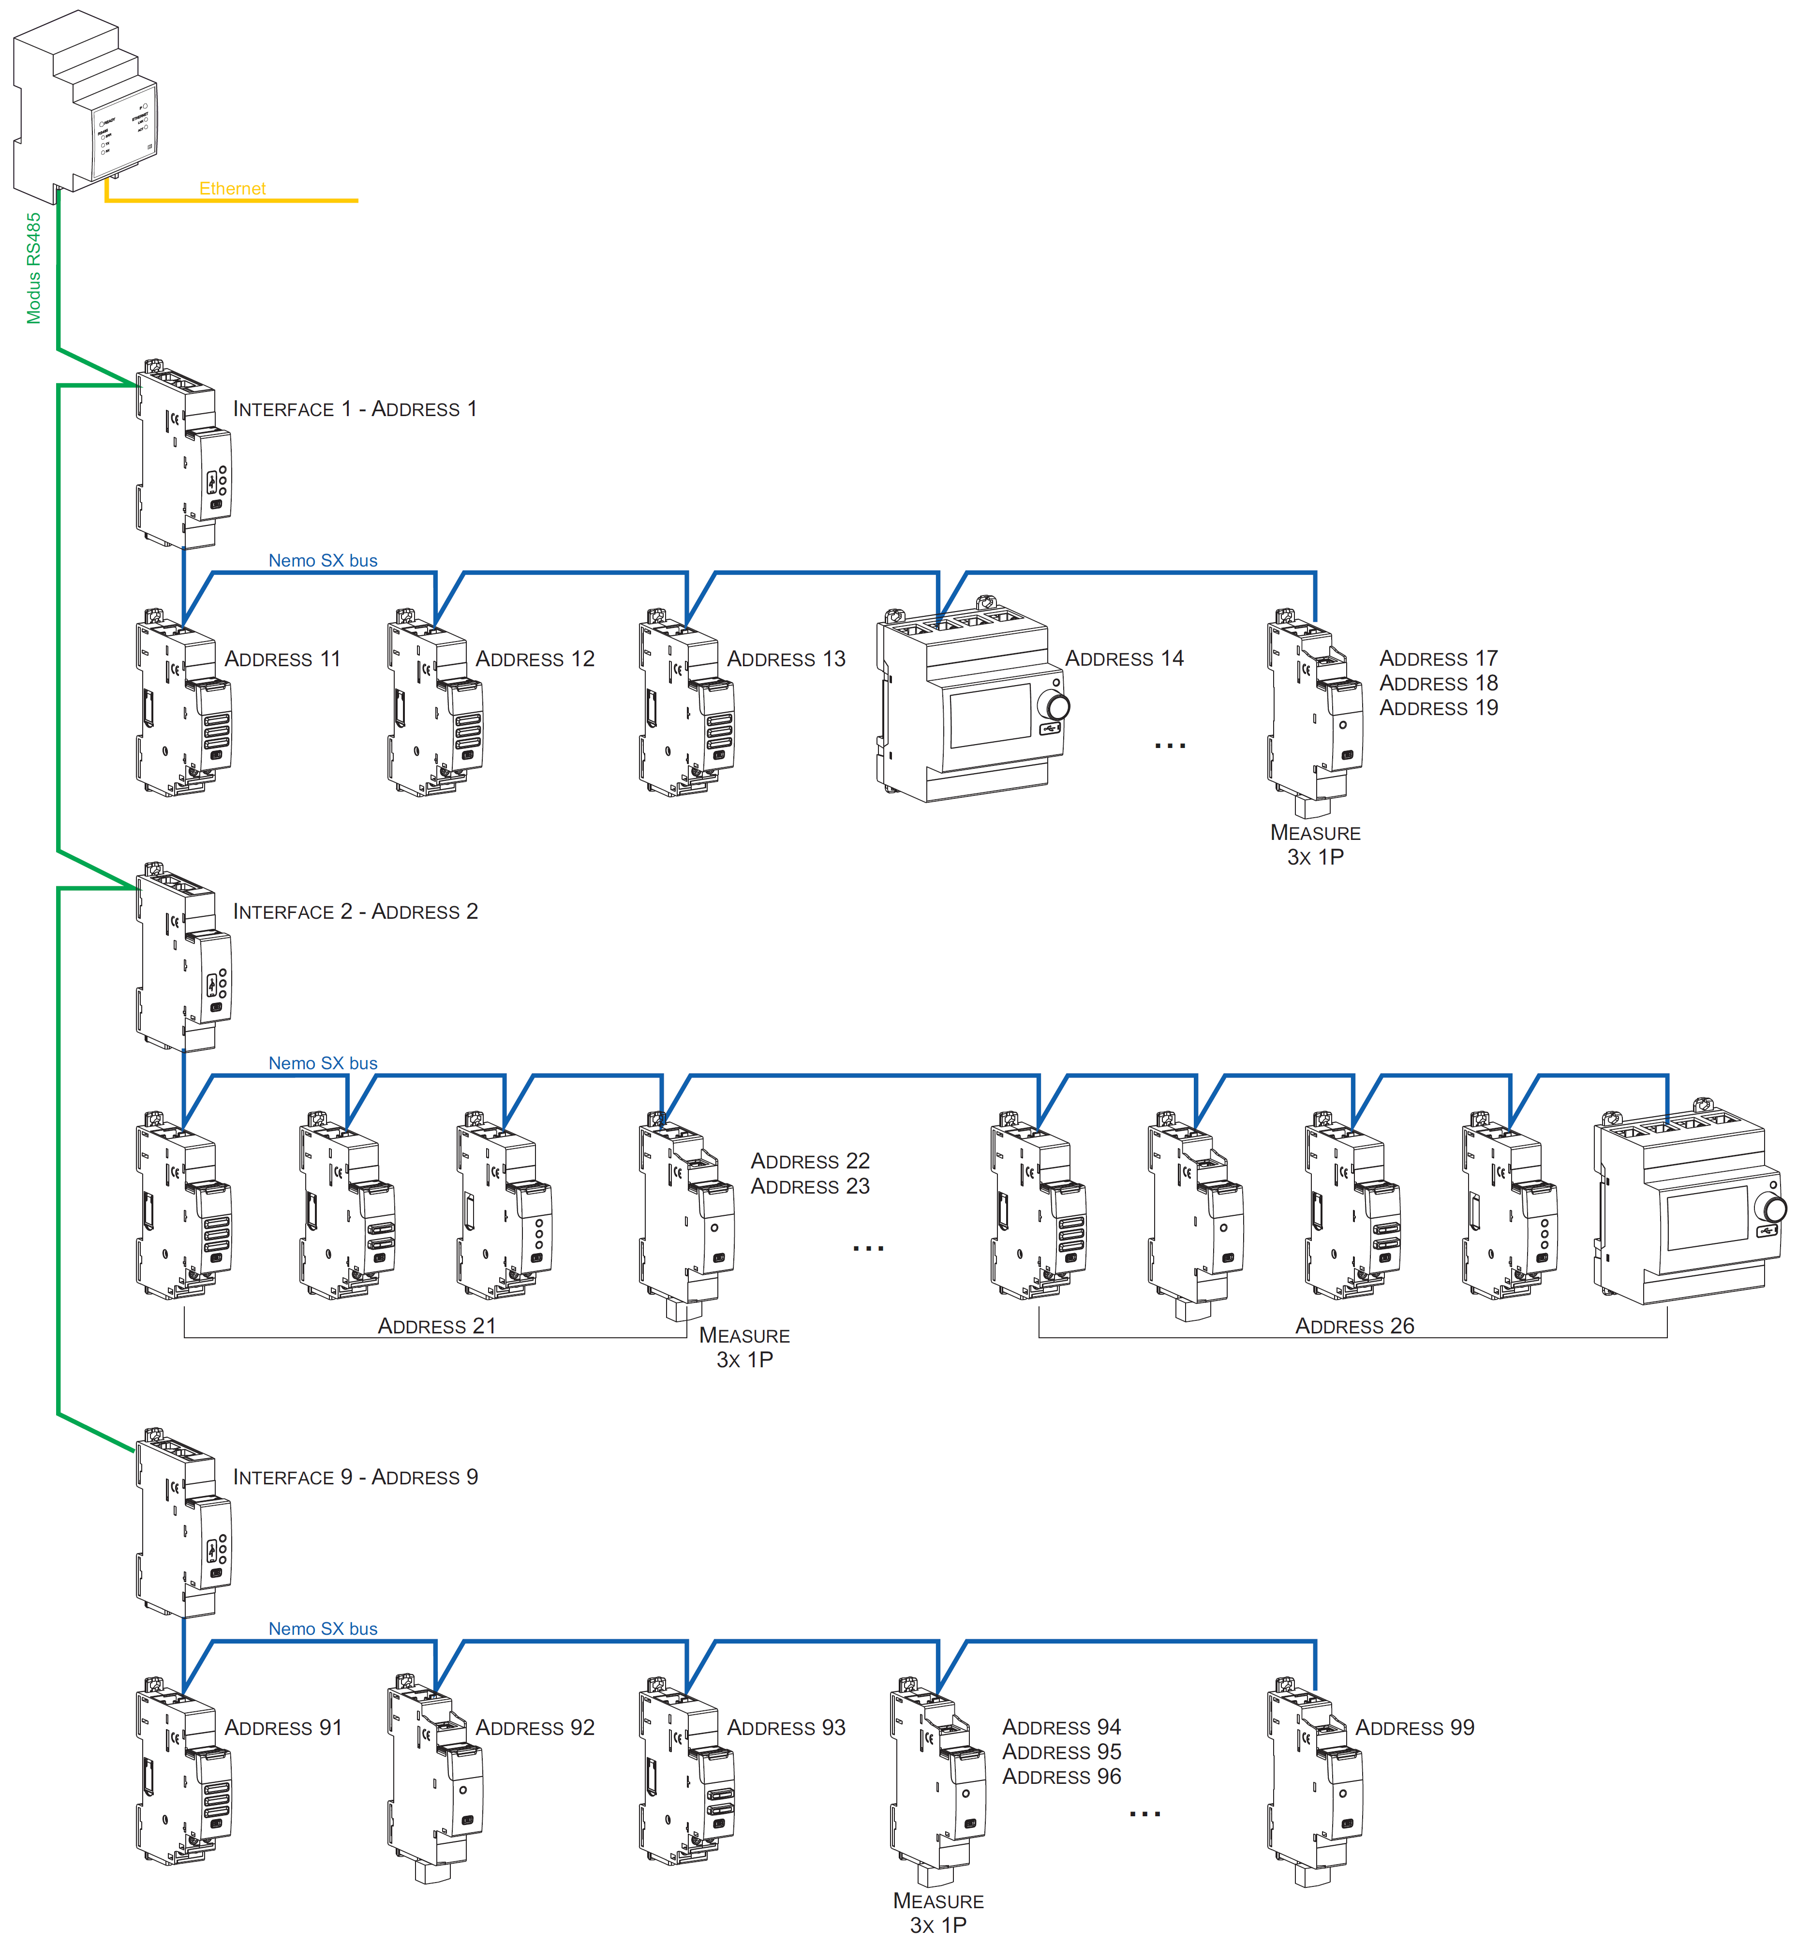
Cat. nos SXIIP,
SXWS10, SXWS2
Consequences for the system architecture:
- for 1 IP/Modbus gateway (cat. no SXIIP):
  - up to 81 Modbus address
  - mandatory limit of max. 9 Modbus/Nemo SX interfaces or max. 1000 m of Modbus cable (cable Belden 9842, Belden 3106A or equivalent) or max. 50 m of Category 6 cable (FTP or UTP).
- for 1 Modbus/Nemo SX Interface (cat. no SXI485):
  - up to 30 Nemo SX modules (ex. 30 devices grouped per functions with addresses from1 to 9)
Note: with local addressing, the Modbus/Nemo SX interface, does the automatic detection of modules (characteristics, functions, configuration...)
 | Technical data sheet: IDP000167EN_05 | Updated: 05/05/2021 |  |  | Created: 31/08/2017

 | Nemo SX - Pulse concentrator module |  |  | Cat. N°: SXMIMP
6. SYSTEM ARCHITECTURES (continued)
6.2 Supervised system (Computer Supervisory System) (continued)
6.2.2 Supervised system with remote addressing (through a computer)
Remote addressing advantages:
- Whole of configuration (addresses and functions) can be done a remotely through the Nemo SX Configuration software
- Configuration software available for free
- Automatic detection of the Nemo SX modules installed in the system (characteristics, functions, configuration...)
- Increased settings possibilities: load shedding function
- Increased addressing: up to 32 Modbus/Nemo SX interfaces
- Increased addressing: up to 247 Modbus addresses in a system
Programming procedure:
. For Nemo SX modules which need some: possible through the lateral DIP-switches of each Nemo SX module or via the configuration software (see § “Module configuration”).
Addressing procedure:
The track wheel must be left in position “0”.
. It is not necessary to address the Nemo SX modules. The track wheel must be left in default position “0”.
. All the addressing/configuring procedure will be done with the Configuration Software (available online for free)
. With remote addressing, the software does the automatic detection of modules installed in the system, but the supervision is not possible until the user assigns the remote address and all the characteristics to each module.
Note: it is mandatory to connect the computer to the different Modbus/Nemo SX interface with a “Type B” micro USB - USB cable (one interface at a time). [For more details, refer to the § “Front USB port” of this document]
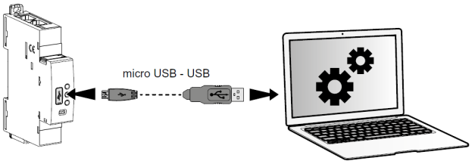

Note for Measure Module “3x single phase”:
This module is to be consider as 3 modules with 3 different Modbus Address. The module takes automatically the two addresses immediately following to the programmed one (e.g. Programmed address = 2, Addresses of the module 2, 3, 4)
 | Technical data sheet: IDP000167EN_05 | Updated: 05/05/2021 |  |  | Created: 31/08/2017

 | Nemo SX - Pulse concentrator module |  |  | Cat. N°: SXMIMP
6. SYSTEM ARCHITECTURES (continued)
6.2 Supervised system (Computer Supervisory System) (continued)
6.2.2 Supervised system with remote addressing (through a computer) (continued)
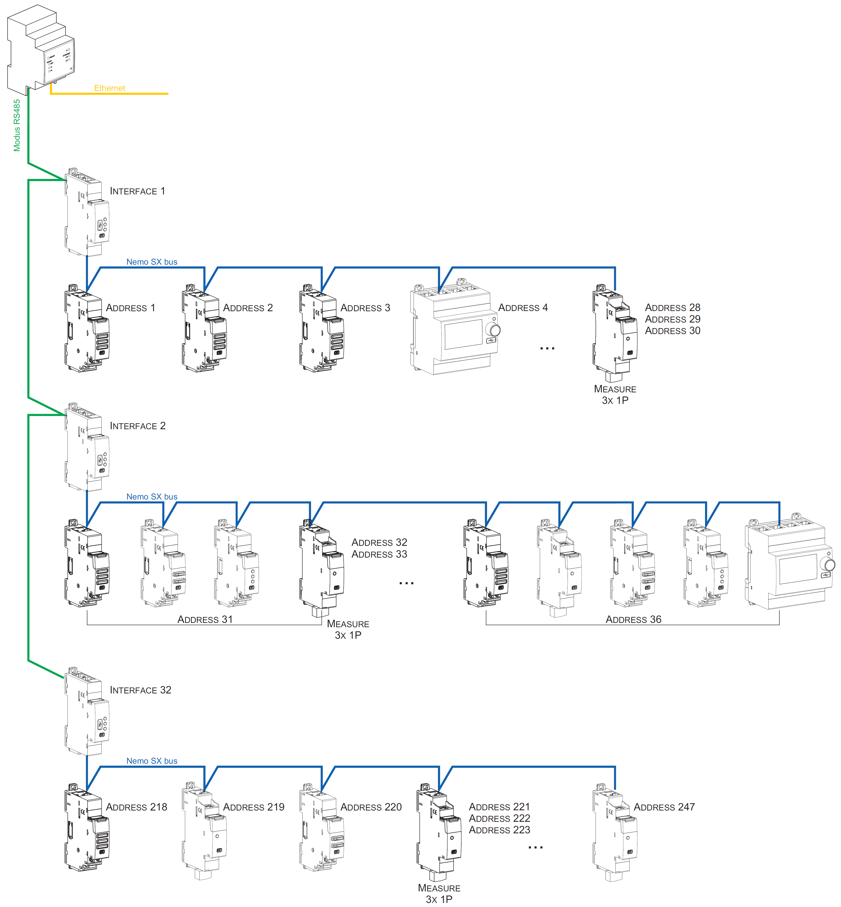
Cat. nos SXIIP,
SXWS10, SXWS2
Consequences for the system architecture:
- for 1 IP/Modbus gateway (cat. no SXIIP):
  - up to 247 Modbus address
  - Because of Modbus: mandatory limit of max. 32 Modbus/Nemo SX interfaces or max. 1000 m of Modbus cable (cable Belden 9842, Belden 3106A or equivalent) or max. 50 m of Category 6 cable (FTP or UTP).
- for1 Modbus/Nemo SX Interface (cat. no SXI485):
  - up to 30 Nemo SX modules or grouped modules (e.g. 30 devices grouped per functions with addresses from1 to 30)
It is possible to assign to several devices the same address with the purpose of grouping different functions, because they are related to the same electrical circuit. For example, it is possible to assign the same address to a multifunction signalling module (cat. no SXMC02), a multifunction control module (cat. no SXM0C1), a measuring module, and so on. In this way on the Nemo SX display or in a supervision system the grouped function will be displayed as a unique “device” with all grouped functions. [Refer to the scheme up here]
 | Technical data sheet: IDP000167EN_05 | Updated: 05/05/2021 |  |  | Created: 31/08/2017

 | Nemo SX - Pulse concentrator module |  |  | Cat. N°: SXMIMP
7. COMPLIANCE AND APPROVALS
Compliance to standards:
. Compliance with Directive on electromagnetic compatibility (EMC) n° 2014/30/EU
. Compliance with low voltage directive n° 2014/35/EU.
. Electromagnetic Compatibility:
IEC/EN 61131-2
. Product standard: IEC/EN62053-31 class B (Annex D)
Environment respect – Compliance with CEE directives:
. Compliance with Directive 2011/65/EU modified by directive 2015/863 (RoHS 2) on the restriction of the use of hazardous substances in electrical and electronic equipment such as lead, mercury, cadmium, hexavalent chromium and polybrominated biphenyl (PBB) and polybrominated diphenyl ether (PBDE) brominated flame retardants from 1st July 2006
. Compliance with the Directive 91/338/EEC of 18/06/91 and decree
94-647 of 27/07/04.
. Compliant with regulation REACH
Plastic materials:
. Halogens-free plastic materials.
. Marking of parts according to ISO 11469 and ISO 1043.
Packaging:
. Design and manufacture of packaging compliant to decree 98-638 of the 20/07/98 and also to directive 94/62/CE.

 | Technical data sheet: IDP000167EN_05 | Updated: 05/05/2021 |  |  | Created: 31/08/2017

